Focus Group for App Design

|  |  |  |  |
| --- | --- | --- | --- |
|  | App Design1(Marvel) | App Design 2 ( | App Design 3 |
| Overall Design | 8 | 7 | 7 |
| User Experience | 7 | 7 | 8 |
| Ease of use | 7 | 8 | 8 |
| Usefulness | 6 | 7 | 9 |

App 1

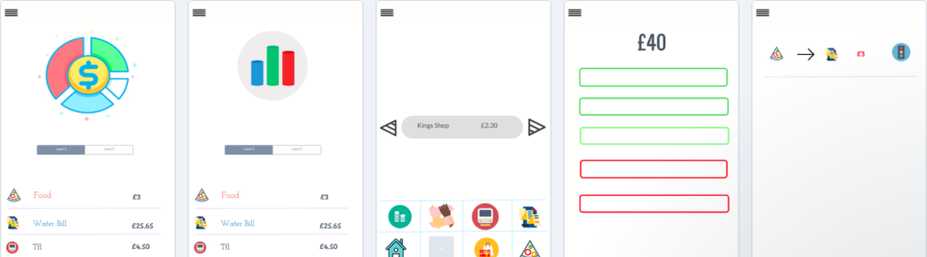

App 2

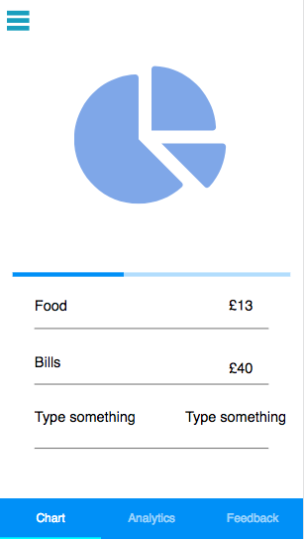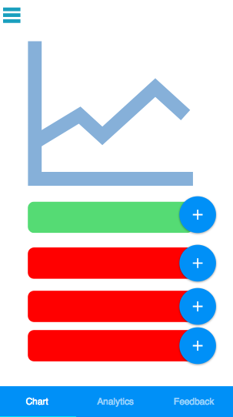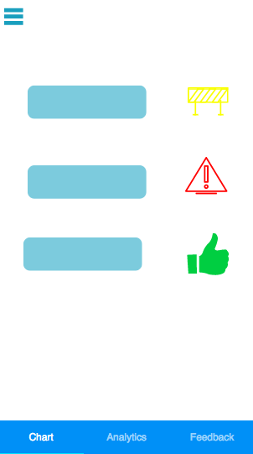

App 3

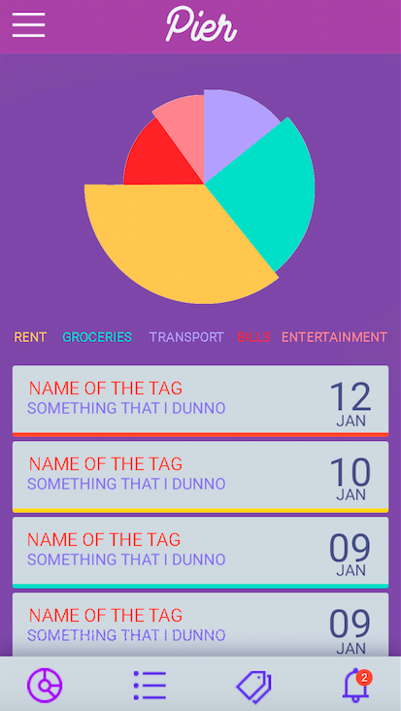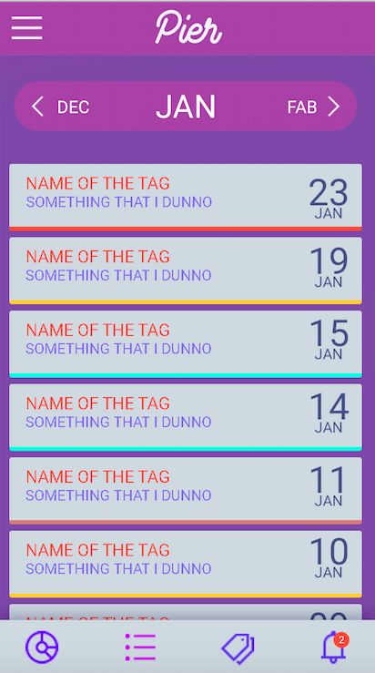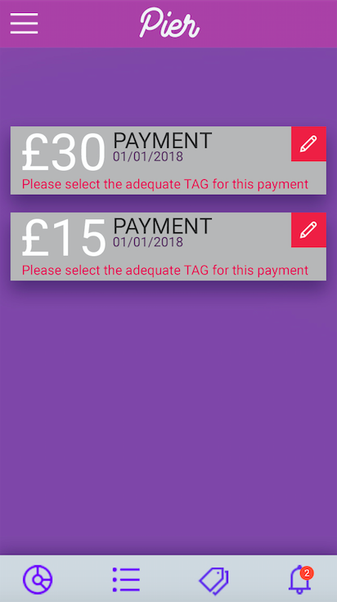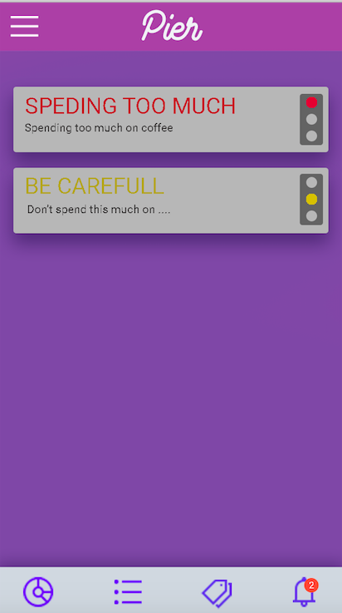

**Breakdown –**

Which App has the best breakdown?

App1

What would you change/add to make it better in your opinion?

I like the colour scheme

Great amount of white space

**Data Analytics -**

Which App has the best Data Analytics ?

App 3

What would you change/add to make it better in your opinion?

Definitely change colour scheme. Keep it simple and white

**Tags-**

Which App has the best Tags?

App3 and 1

What would you change/add to make it better in your opinion?

App3 because its easier

App1 beacause its simple (logo)

**Alerts**

Which App has the best Alerts?

App 2

What would you change/add to make it better in your opinion?

Recognisable

**Input Method**

Method 1 – Leave to side bar-

Method 2 – Put in tab – in tab because of instant input

**Any other comments/ Suggestions**

Bar chart not needed

App2- change the first screen and second timing format